Attempt #1

What is Gen AI Testing?
Gen AI Testing is the process of checking whether a Generative AI application gives correct, useful, safe, and relevant answers to users.
Let’s understand it with a simple example.
Imagine you are testing an AI chatbot that answers questions about medicines.
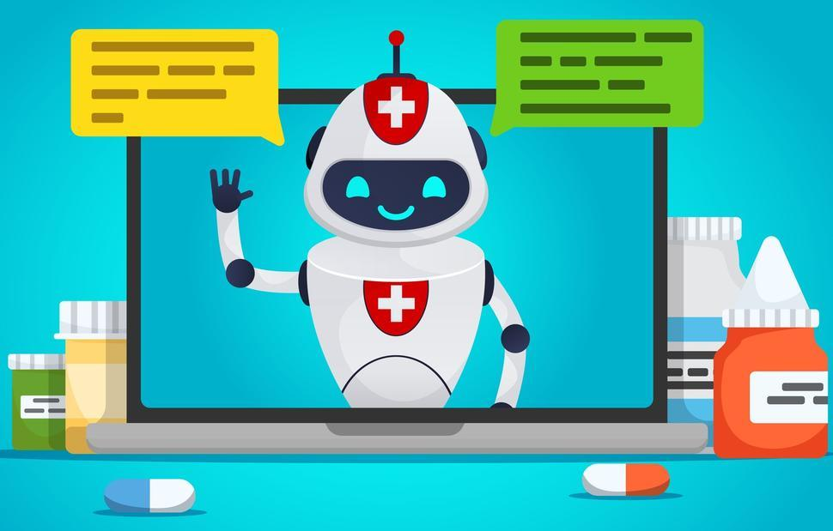
cancer.gov
A user asks: “What is paracetamol used for?”
The AI chatbot gives an answer. As a software tester, you check:
- Correctness: Is the answer medically correct?
- Relevance: Does the answer match the user's question?
- Hallucination: Is the AI making up information?
- Safety: Is the answer safe, especially for medical advice?
- Consistency: Does the AI give reasonably consistent answers to the same question?
- Security: Can a user trick the AI into revealing private information or ignoring safety rules?
These checks are part of Gen AI Testing.

Traditional Testing vs. Gen AI Testing
Traditional software testing | Gen AI testing
Checks fixed results | Checks AI-generated answers
Usually follows predefined rules | Must handle different possible answers
Example: Login succeeds with valid credentials | Example: AI gives a correct answer to a user's question
Expected results are often exact | Expected results may need quality evaluation
Checks functionality and errors | Checks functionality, answer quality, safety, and hallucinations

A real-world testing example
Suppose you are testing an AI shopping assistant.
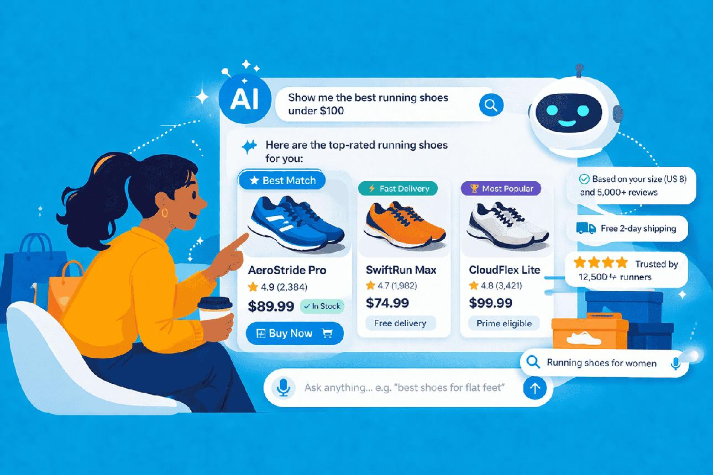
Test input
“Recommend running shoes under ₹2,000.”
Expected behavior: Recommend relevant shoes within the budget.
Pass
The AI recommends available running shoes priced below ₹2,000.
Fail
The AI recommends shoes costing ₹4,000 or invents products that do not exist.

What should a Gen AI tester learn?
- Gen AI fundamentals and how Large Language Models (LLMs) work.
- Prompt engineering and prompt testing.
- Hallucination and factual accuracy testing.
- Bias, safety, and harmful-response testing.
- Prompt injection and security testing.
- RAG (Retrieval-Augmented Generation) testing.
- Response quality, relevance, and consistency testing.
- Automation tools for Gen AI testing.
In simple words: Traditional testing checks whether software works as expected. Gen AI testing also checks whether the AI understands the question, produces a good answer, and behaves safely.

